*Florida International University*

*School of Computing and Information Sciences*

Software Engineering Focus

Feature Document

User Story ID # 311

**Name:** Set Watch Order Map Default Position Based on Longitude and Latitude from Site Settings.

**Team Member(s):** Darilys Pereira

**Project:** Virtual Roll Call 4.0

**Product Owner(s)**: Jason Cohen

**Mentor(s)**: Juan Caraballo

**Instructor**: Masoud Sadjadi

**User Story Name:** Set Watch Order Map Default Position Based on Longitude and Latitude from Site Settings.

* Description: **As an** Administrator I **would like** the watch order map default position to be set to the longitude and latitude from site settings **so that** the map can be adjusted based on police department location.

Acceptance Criteria

* Provide a section in Site Settings to set the default Longitude and Latitude for watch order map settings.
* Watch Order map should be positioned based on the values entered in the settings.

**Use Case**

* Name: Change LatLang
* Actor: Administrator
* Preconditions:

1. System is up and running
2. Administrator has successfully logged into the system.
3. Connection to the database has been established.

* Description:

1. Administrator clicks on the Site Settings side menu under the Administrator section of the application.
2. Administrator enters the time in minutes under the Session Timeout section of Site Settings.
3. Administrator clicks the Update button.

**Use Case Diagram**



**Sequence Diagram**

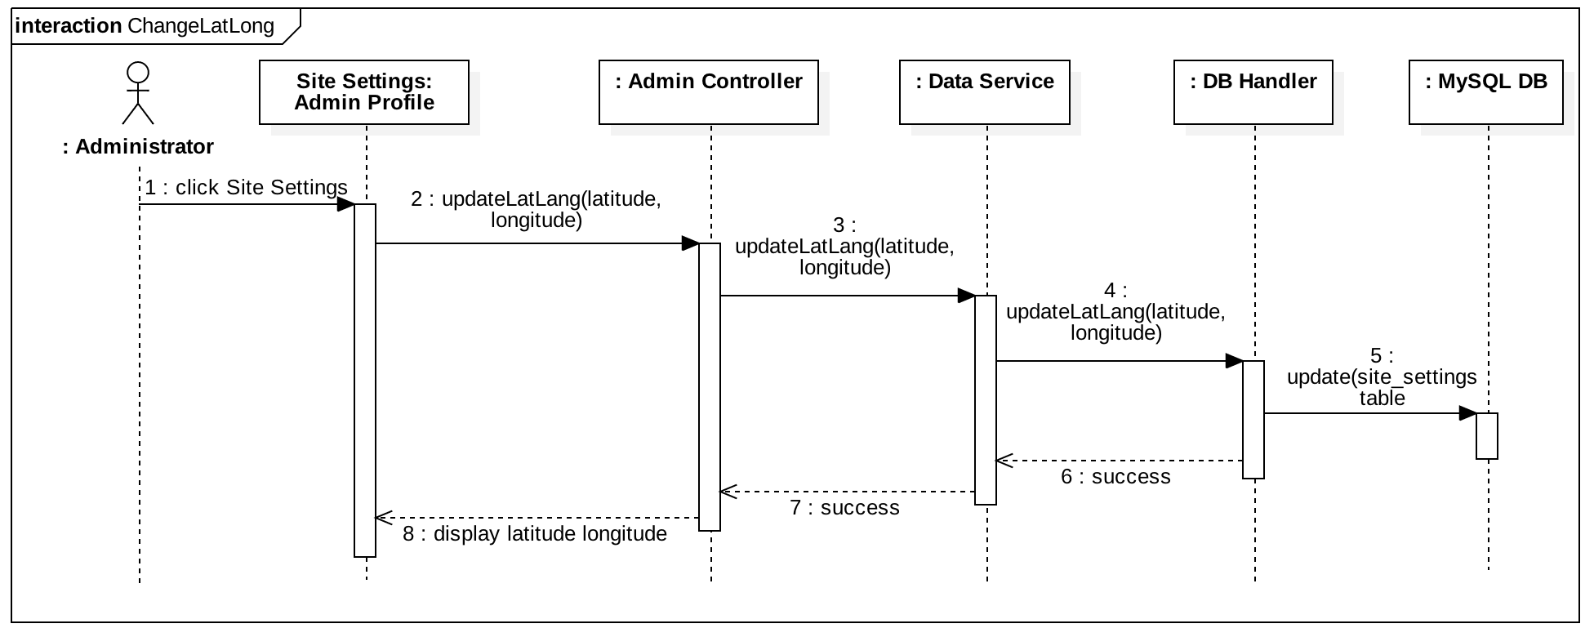

**Class Diagram**

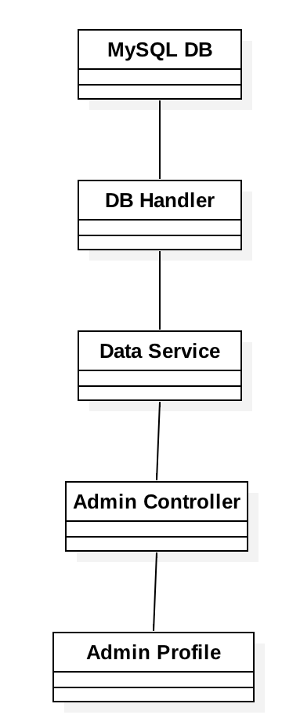

**Unit Test**

* Test case ID: User Story 311 - Change Latitude Longitude-U1
* Description/Summary of Test: Verify new latitude and longitude are updated accordingly in the system.
* Pre-condition:

1. User is logged in.
2. User in the the Site Settings page under Administrator menu.

* Expected Results: New entry should be saved in the database. Confirmation message should be displayed to the user upon successfully updating fields. View of current Site Settings should retrieve new data.
* Actual Result: Updates were stored in the database correctly. Success message was displayed to the user. Site Settings view was updated displaying the new information just entered.
* Status (Fail/Pass): Success.

**Integration Test**

Tested system by:

* Updating the default latitude and longitude to different values.
* Navigating to the Watch Order page and verifying map center was positioned based on the information entered in the Site Settings.
* Viewed existing watch orders in the map.
* Reviewed the detailed information in the map for all watch orders.
* Created a new watch order and verified map was positioned at the default center and could be repositioned to the watch order location by scrolling.
* Verified Map can be seen in full screen mode.

Status : Passed.

**Visual User Guide**

